

Computer Networks

Lab Report

Name ：谭演锋

Student ID ：202130100456

Class ：计算机全英联合班

Collaborator(s) :

# Task 1 Network Traffic Analysis

**Purposes and tasks:**

（1）Learn the use of wireshark. You can do this task on your own PC and own LAN.

（2）Learn analysis of network traffic caught.

（3）Explain TCP hand-shaking process.

（4）Learn how TCP hand-shaking failure can be handled.

（5）Analysis ARP packets

**Steps**:

**1. Setting up experimental environment** (skip this step, if your environment has all been set up)

（1）Wireshark

（2）PC connected to network

**2. Basic operations on Wireshark**

（1）Monitor on a particular network interface

Select a network showed in the Wireshark and click the “Start capture”



figure1: Monitor a particular network in Wireshark

Then we can Monitor on a particular network interface. Here is it UI.

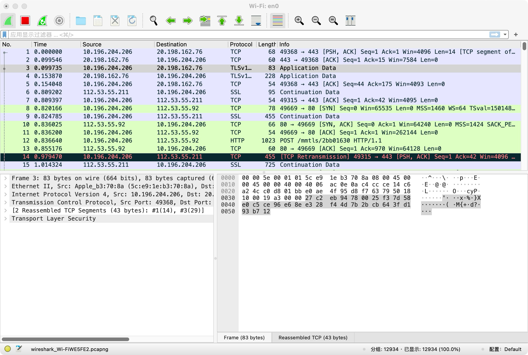

figure2: After clicking “Start caputure”

1. Capture particular packets.

Use the filter above the UI, we can capture particular packets by giving particular filtering condition.

Here is the example:

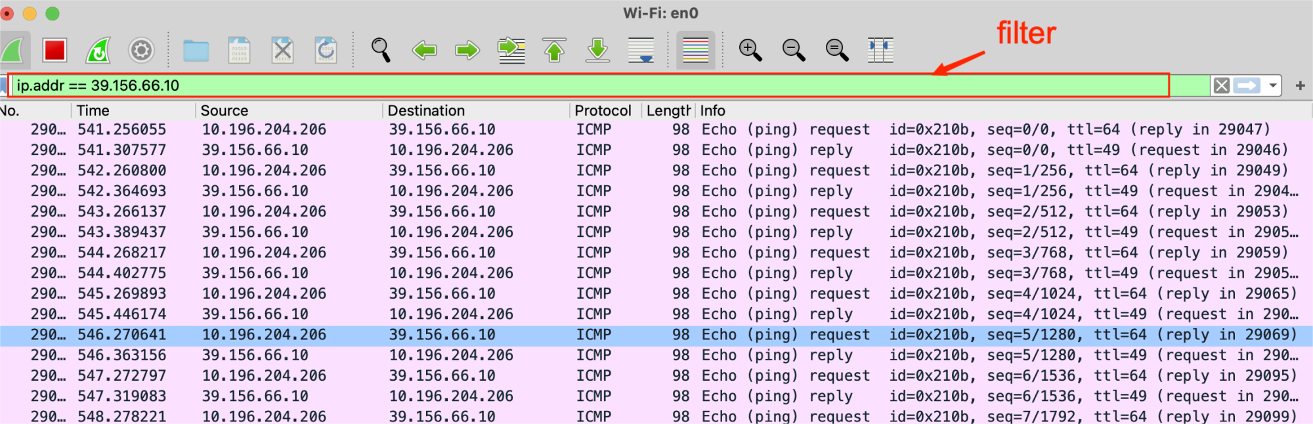

figure3: Filter in Wireshark

1. **Record an example of a successful TCP three-hand-shaking**

Following is the figure showing the TCP three-hand-shaking process.

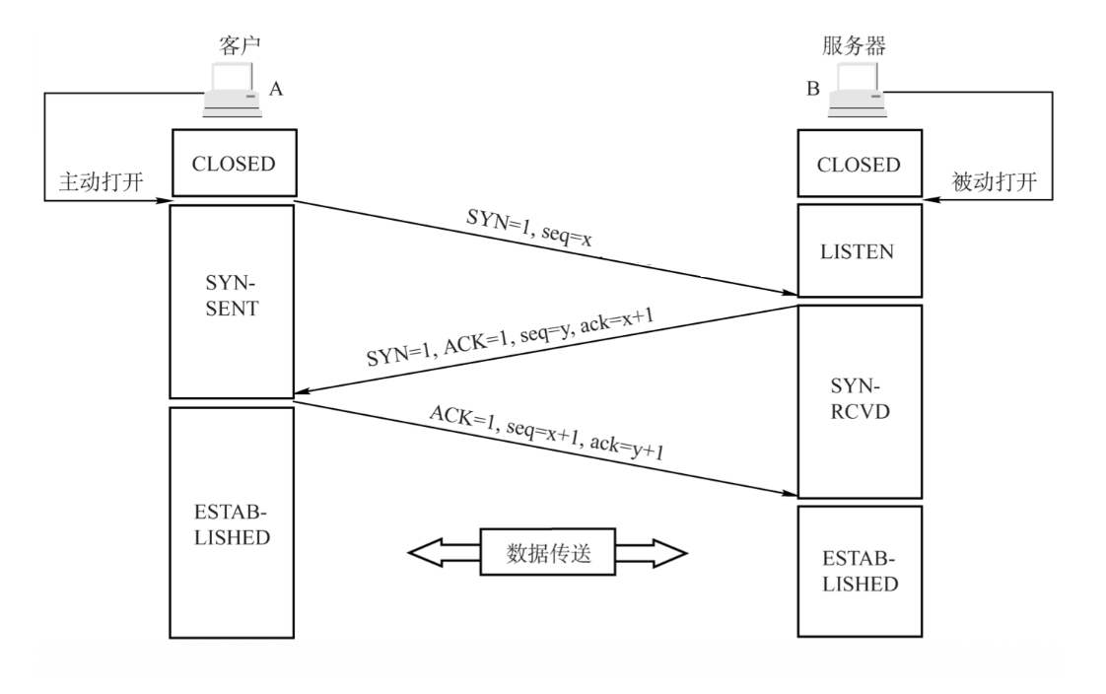

figure4: TCP three-hand-shaking process

First hand shaking:

The client sends a connection request message without application layer data.

SYN=1,ACK=0, seq=x (random)

Second hand shaking:

The server allocates cache and variables for the TCP connection, and sends an acknowledgment message to the client, allowing the connection without application layer data.

SYN=1, ACK=1, seq=y(random), ack=x+1

Third hand shaking:

The client allocates cache and variables for the TCP connection and sends a confirmed acknowledgment to the server, which may carry data.

SYN=0, ACK=1, seq=x+1, ack=y+1

Following is how to record a successful TCP three-hand-shaking.

First we ping baidu.com in the terminal for its IP address.



figure5: ping baidu.com

Then we use command “Telnet” to connect the Baidu.com. The Telnet command establishes a connection with the target computer. Be sure we should add the port number behind the IP address to make sure we can make a successful TCP three-hand-shaking.

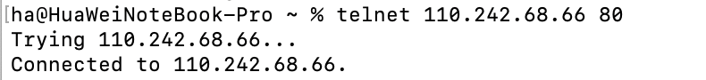

figure5: Telnet IP address

Then we can observe the TCP three-hand-shaking.

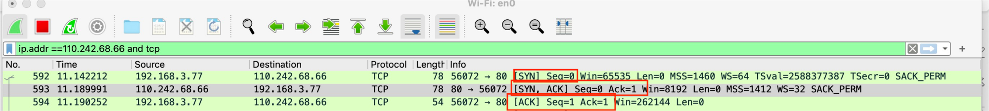

figure6: Three-hand-shaking of TCP

Following is the details of it.

**First hand-shaking**

At first, client send request with the seq =0, not set Acknowledgment and set Syn =1 to make TCP connection

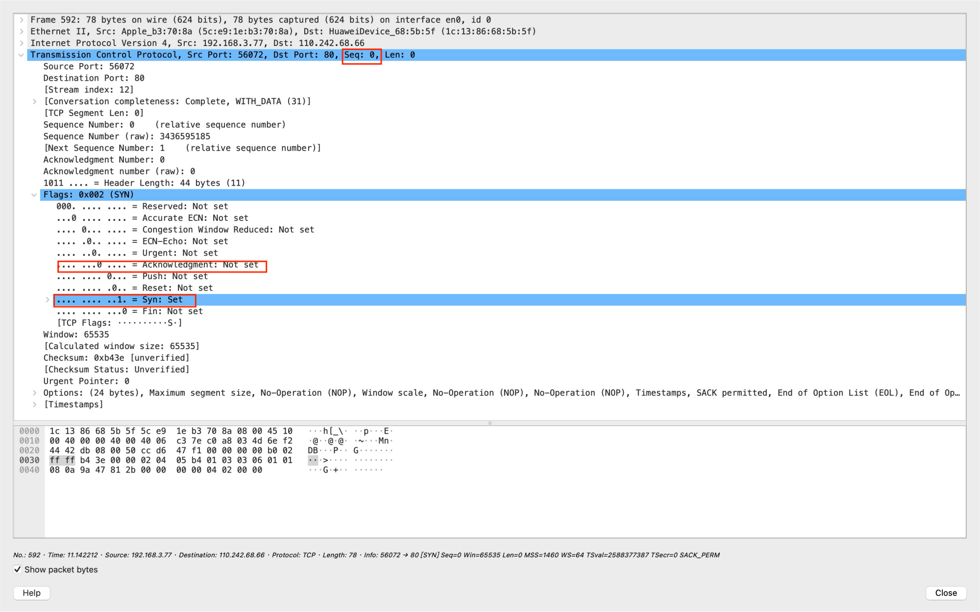

figure7: Detail of first hand-shaking

**Second hand-shaking**

Second, sever replies with the seq =0, set Acknowledgement and reply with Ack=1 for making acknowledgement of client message and set Syn =1 to make TCP connection

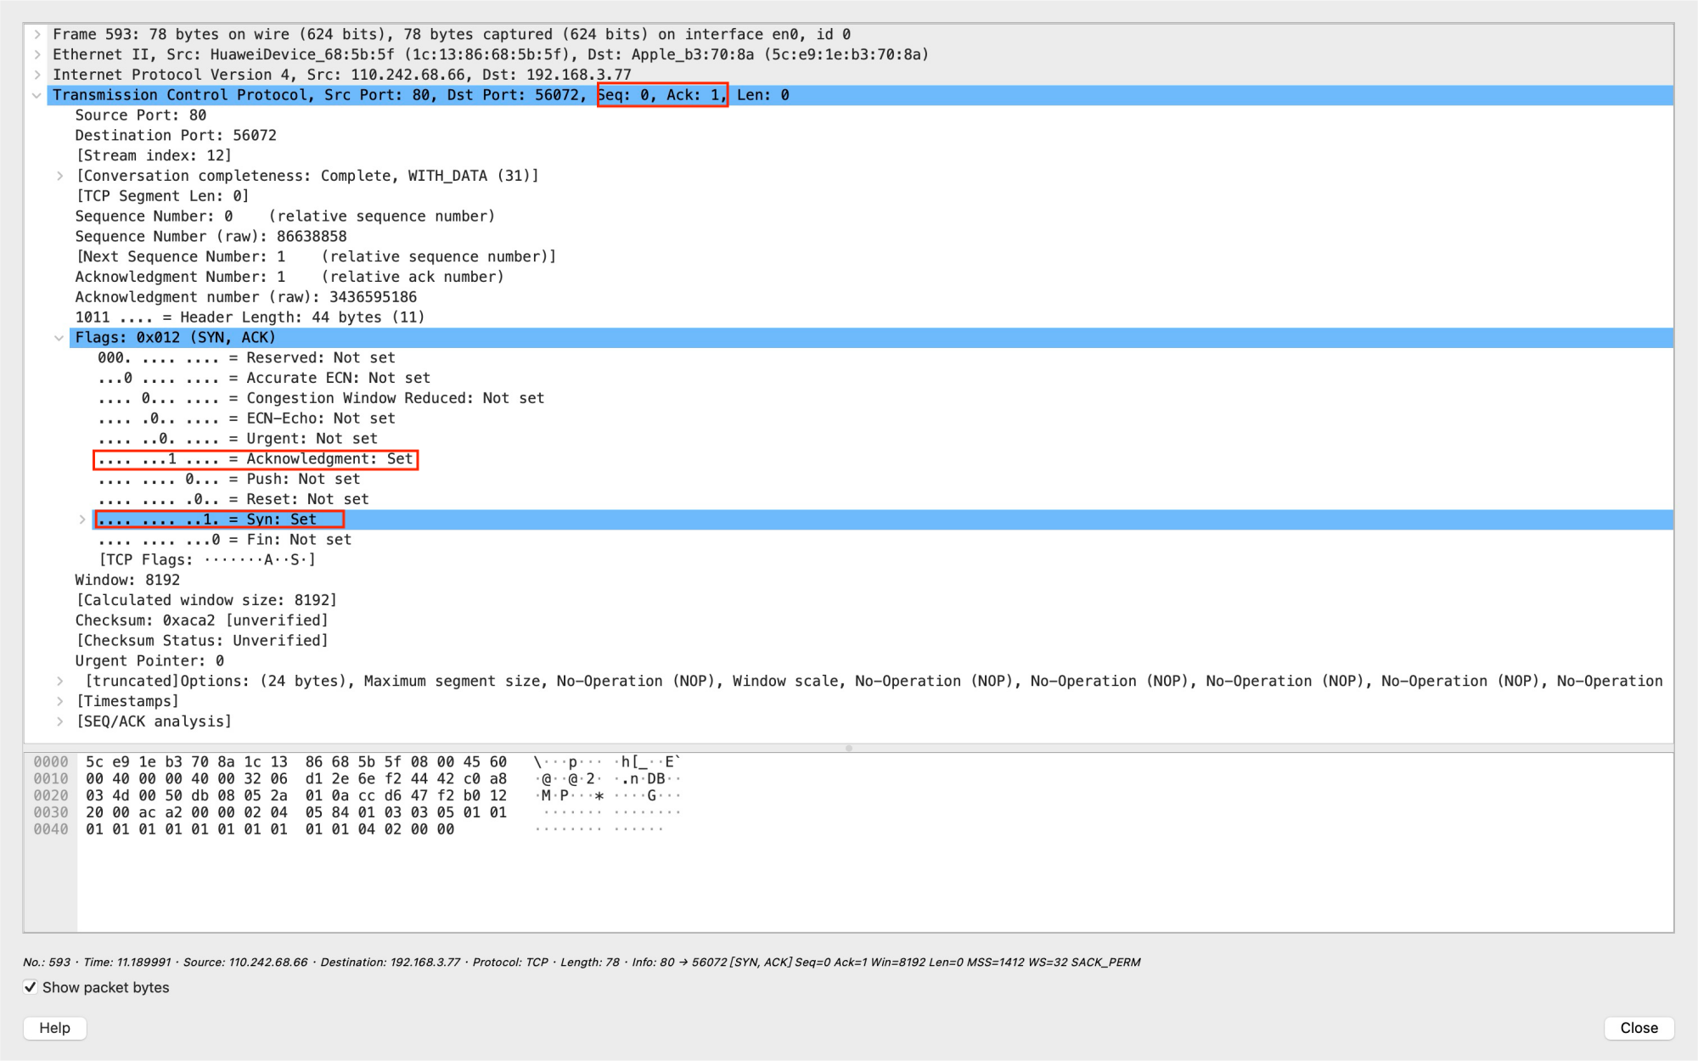

figure8: Detail of second hand-shaking

**Third hand-shaking**

Third, client send message with the seq =1(0+1), set Ackowledgement and relpy with Ack=1 for making acknowledgement of sever messgae and set Syn =0 since TCP connection has been set.

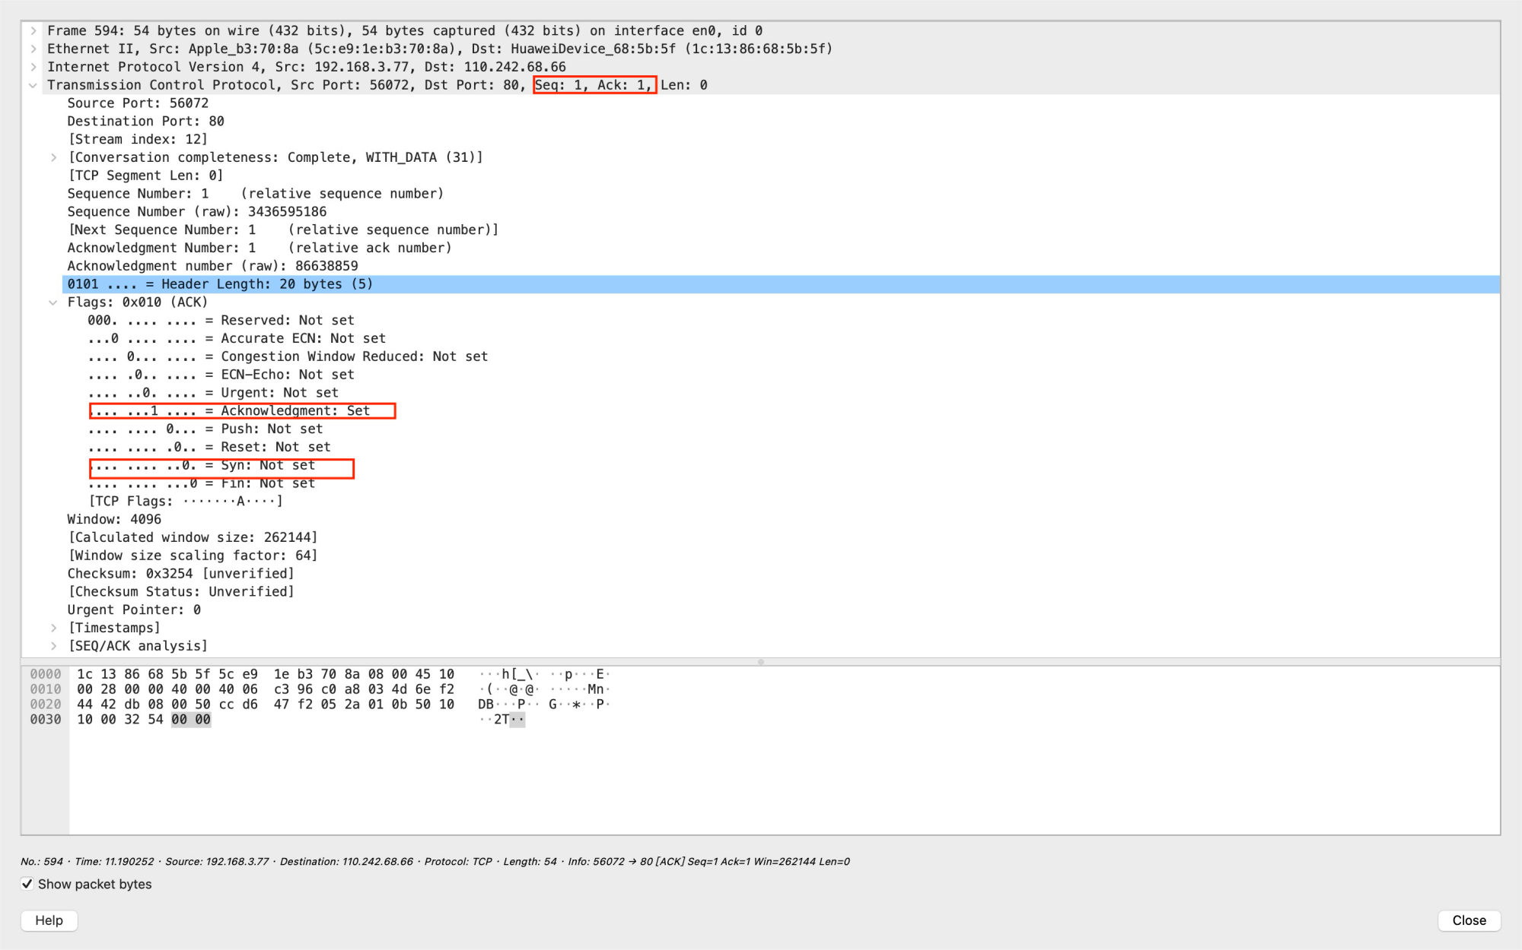

figure9: Detail of thrid hand-shaking

1. **Record an example of hand-shaking failure**

To record the hand-shaking failure, we can telnet the baidu.com IP address with wrong ports(40).

Following is the example:

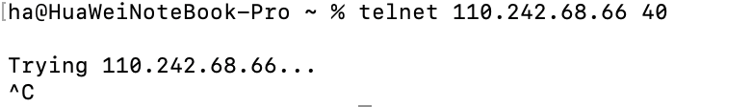

figure10: Telnet with wrong port

Then we can observe the failure of hand-shaking by Wireshark. From the picture we find that the Source try to send message to the Destination, but it doesnot get the reply. Threefore it always tried to retransimission.

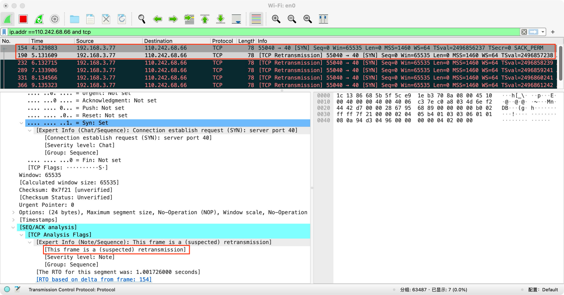

figure11: Hand-shaking failure example

1. **Monitoring ARP packets.**

ARP is responsible for mapping IP addresses to physical addresses. If a computer needs another computer’s MAC address, which is not in the local ARP cache table, it will broadcast a request to all host.Ffirst in local network, if it is no exist then is whole network by router. When the another computer receives the ARP request, it will reply with its MAC address.

To Monitoring ARP packets we can us “sudo arp -d -a” to clear ARP cachet.

Then we can ping a IP address to get the ARP packets.

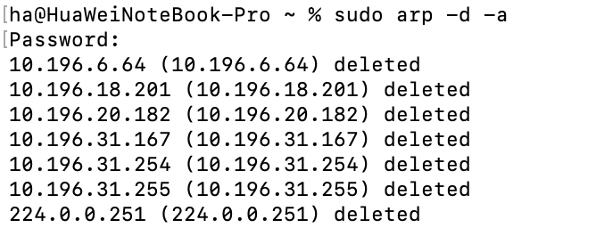

figure12: How to detect ARP packerts

Here is the example request packets in the local network by filter “arp”, we can see its “Address Resolution Protocal” is request. It is saying “Who Has 10.196.31.254? Tell 10.196.26.202”. Since it is Broadcast, it set destination all 1. The compueter does not know the MAC address, so it sets Taget MAC address all 0.

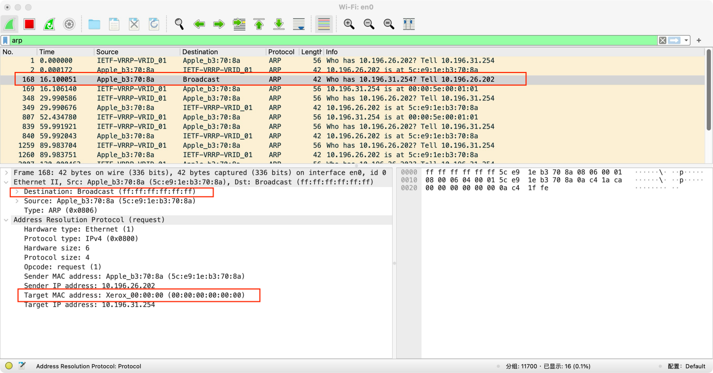

figure12: ARP boardcast request packerts

Here is the example reply packets in the local network, we can see its “Address Resolution Protocal” is reply. It is saying “10.196.31.254 is at 00:00:5e:00:01:01” for replying MAC address. The Taget MAC address is the MAC address who send request.

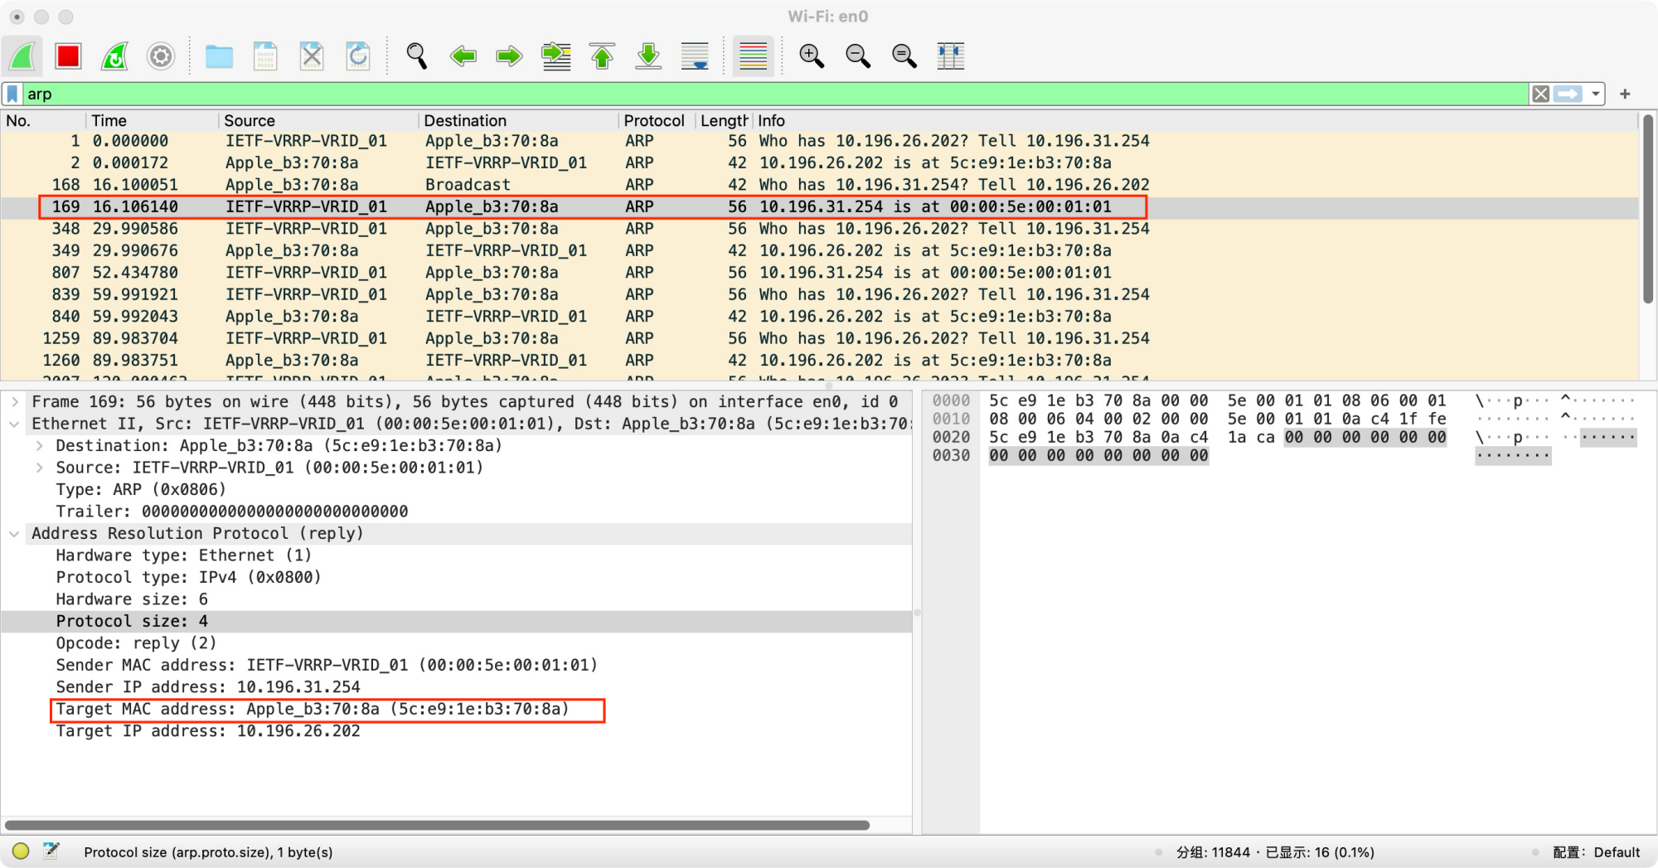

figure13: ARP reply packerts

**6. Monitoring ICMP packets**

ICMP (Internet Control Message Protocol) is a connectionless protocol used for transmitting error reports and control information. It is a crucial protocol with significant implications for network security. ICMP belongs to the network layer and is primarily employed for the exchange of control information between hosts and routers. This includes reporting errors, exchanging restricted control, and conveying status information. ICMP messages are automatically sent when encountering situations such as the inability to access the target of IP data or when IP routers cannot forward data packets at the current transmission rate.

Here is an example of ICMP packets used to detect connection.

First we “ping baidu.com” to dectect connection for six times.

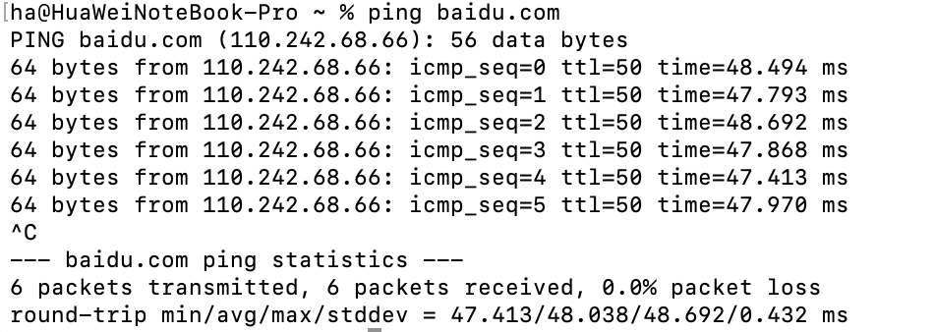

figure14: ping command in the terminal

Then filter ICMP by Wireshark. In the picture, there are 12 ICMP packets, since one ping has two ICMP packets one for requesting and one for replying.

Watching details in the ICMP packets. In ICMP packet “Tpye:8” means request, “Tpye:0” mean reply. “Checksum” used to detect the correctness of packets

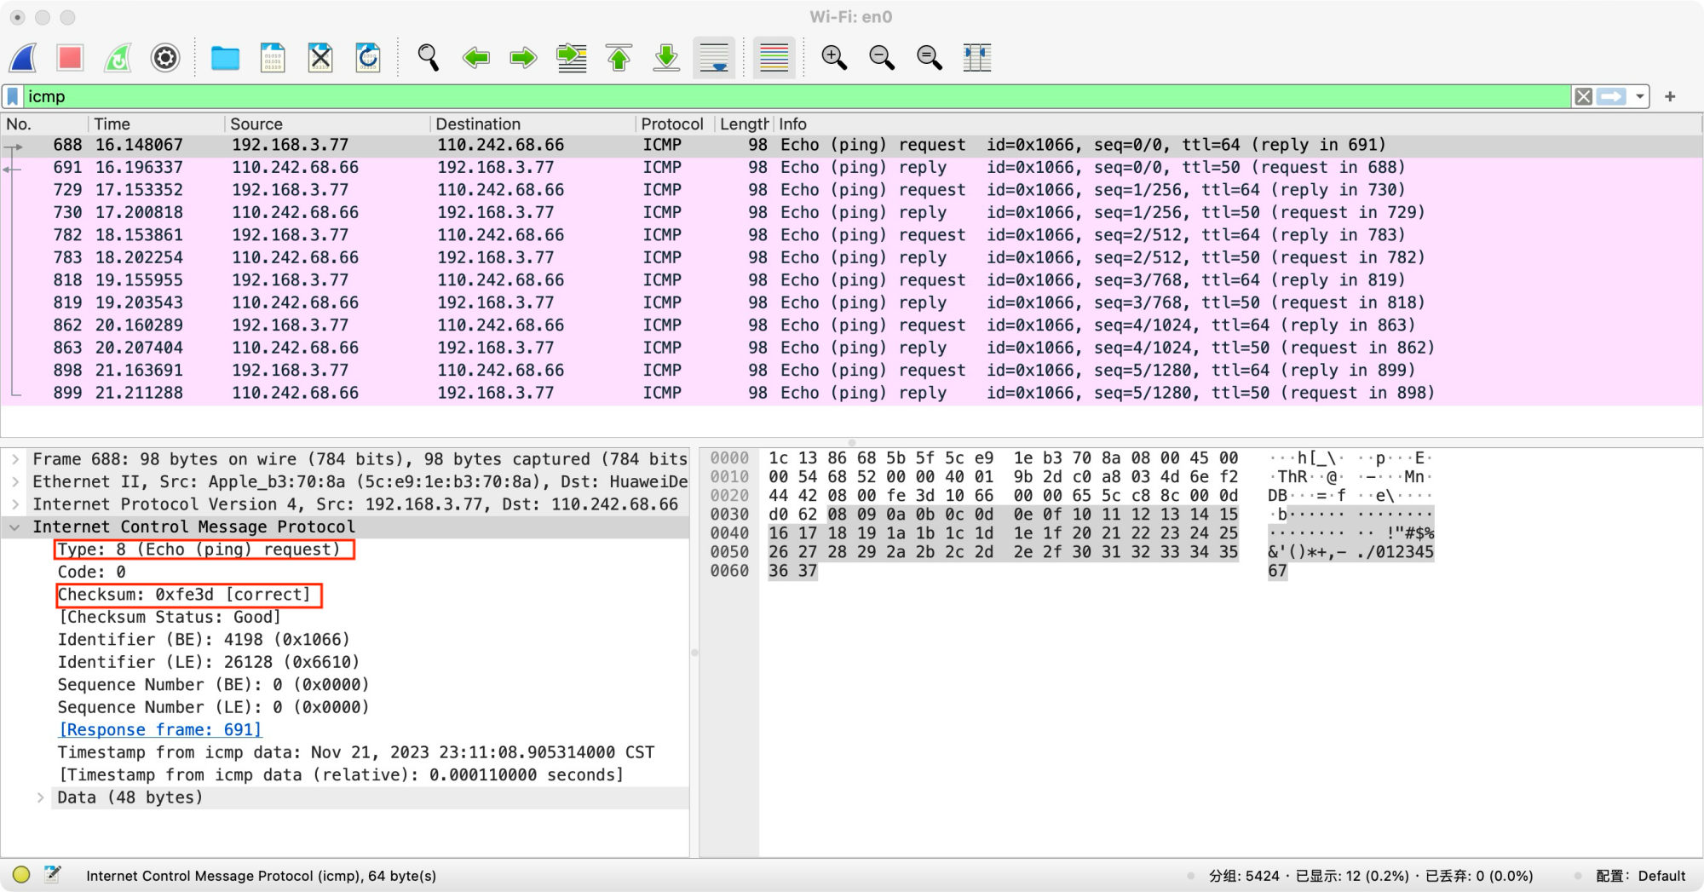

figure15: ICMP reqest packerts

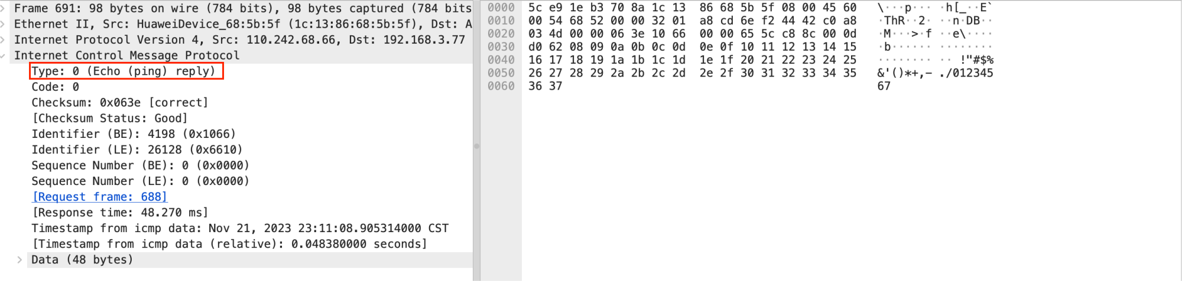

figure16: ICMP reply packerts

# Conclusion

**Task1:**

From task 1, I first learn how to use the Wireshark for monitoring the internet and caputuring packets, which gives me a deeply understanding of network communication. After I finish the experiment of TCP hand-shaking process, I learn about how the TCP make connection between two computer. I have learned some details implementation of TCP by reading its packets infomation carefully. Then I tried to make the TCP connection failure by setting the wrong port and found that if the TCP connection fails (getting no reply), my computer always tries to make connection by transmission first hand shaking packets. Then I focus on the ARP protocol which is used to get MAC address. First the computer will broadcast “who has xxx tell xxx”. Then someone will reply it by a APR reply packets saying that “xxx is at xxx” . The computer’s arp cache will store it. Finlly the next time the computer wants the same MAC address, it will ask directly instead of broadcast. Then I make a experiment to detect the ICMP packets by pinging baidu.com. Knowing the usages of ICMP and one of them is detecting the connnection.